**CECS 572 Computer Network Interoperability IP Addressing Assignment**

1. Find the following values for the given IP addresses:

• Subnet mask (in decimal dotted values)

• Range (Network ID and Broadcast ID)

• Valid Hosts

• Number of subnets

Solution:

|  |  |  |  |  |  |
| --- | --- | --- | --- | --- | --- |
| IP Address | Subnet Mask | Network ID | Broadcast ID | Valid Host | No. of Subnets |
| 15.10.100.10/17 | 255.255.128.0 | 15.10.0.0/17 | 15.10.127.255/17 | 32766 | 512 |
| 205.125.125.133/19 | Invalid because it is a Class C IP Address and the CIDR is 24, which is incorrect | | | | |
| 150.50.25.50/22 | 255.255.252.0 | 150.50.24.0/22 | 150.50.27.255/22 | 1022 | 64 |
| 197.34.109.250/26 | 255.255.255.192 | 197.34.109.192/26 | 197.34.109.255/26 | 62 | 4 |
| 172.26.5.254/23 | 255.255.254.0 | 172.26.4.0/23 | 172.26.5.255/23 | 510 | 128 |
| 221.245.36.36/28 | 255.255.255.240 | 221.245.36.32/28 | 221.245.36.47/28 | 14 | 16 |
| 136.169.168.167/29 | 255.255.255.248 | 136.169.168.160/29 | 136.169.168.167/29 | 6 | 8192 |

2. Using the given FLSM network provide subnetting to meet the IP requirements. For each case provide number of networks, subnet mask in CIDR form, and list all possible network IDs and Broadcast IDs

a. Req = 63 hosts, using a C-class address network 192.168.168.0/24

b. Req = 5 hosts, using a C-class address network 190.33.0.0/16

c. Req = 500 hosts, using a B-class address network 172.16.0.0/16

d. Req = 5000 hosts, using a B-class address network 199.1.0.0/16

e. Req = 30000 hosts, using a B-class address network 130.18.0.0/16

f. Req = 280000 hosts, using a A-class address network 10.0.0.0/8

Solution:

|  |  |  |  |  |  |  |
| --- | --- | --- | --- | --- | --- | --- |
| **Req** | **IP Address** | **No. of Networks** | **No. of Subnets** | **Subnet Mask** | **Network ID** | **Broadcast ID** |
| **63** | **192.168.168.0/24** | 126 | 2 | 255.255.255.128/25 | 192.168.168.0/25 | 192.168.168.127/25 |
| 192.168.168.128/25 | 192.168.168.255/25 |
| **5** | **190.33.0.0/16** | Invalid because the given IP address if of Class B but it is mentioned as Class C in question | | | | |
| **500** | **172.16.0.0/16** | 510 | 128 | 255.255.254.0/23 | 172.16.0.0/23 | 172.16.1.255/23 |
| 172.16.2.0/23 | 172.16.3.255/23 |
| 172.16.4.0/23 | 172.16.5.255/23 |
| ….. | ….. |
| 172.16.254.0/23 | 172.16.255.255/23 |
| **5000** | **199.1.0.0/16** | Invalid because the given IP address if of Class C but it is mentioned as Class B in question | | | | |
| **30000** | **130.18.0.0/16** | 32766 | 2 | 255.255.128.0/17 | 130.18.0.0/17 | 130.18.127.255/17 |
| 130.18.128.0/17 | 130.18.255.255/17 |
| **280000** | **10.0.0.0/8** | 524286 | 32 | 255.248.0.0/13 | 10.0.0.0/13 | 10.7.255.255/13 |
| 10.8.0.0/13 | 10.15.255.255/13 |
| 10.16.0.0/13 | 10.23.255.255/13 |
| 10.24.0.0/13 | 10.31.255.255/13 |
| ….. | ….. |
| 10.248.0.0/13 | 10.255.255.255/13 |

3. Using VLSM provide subnetting to meet the requirements in each LAN for the following WAN. For each LAN provide network ID, Broadcast IDs, subnet mask in CIDR form, and the usable or routable range of IPs. Hint: You should begin your work by counting the total number of IPs required in the entire WAN; remember to also consider the extra 2 non-routable IPs (for network and broadcast) on each LAN and point-to-point links. Then you decide which full class subnet will suffice the requirements. Use one of the following prefixes:

For Class A - 10.0.0.0/8

For Class B - 172.30.0.0/16

For Class C - 192.168.4.0/24

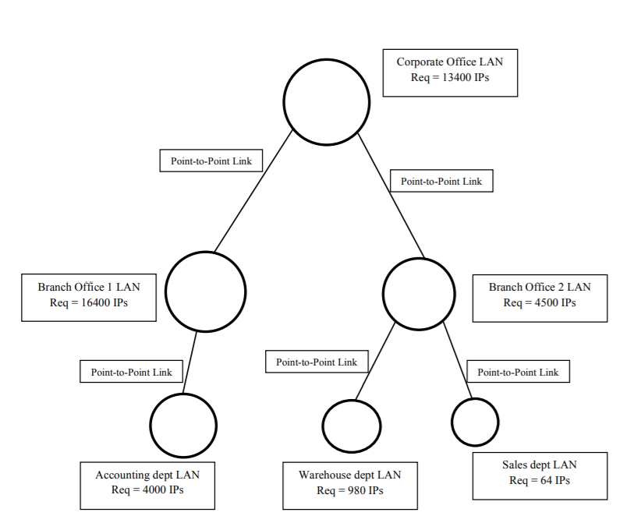

Solution:

Rearranging based on the number of required IPs:

* Branch Office 1 LAN Req = 16400 IPs
* Corporate Office LAN Req = 13400 IPs
* Branch Office 2 LAN Req = 4500 IPs
* Accounting dept LAN Req = 4000 IPs
* Warehouse dept LAN Req = 980 IPs
* Sales dept LAN Req = 64 IPs

|  |  |  |  |  |
| --- | --- | --- | --- | --- |
| Req No. of IPs | Network ID | Broadcast ID | Subnet Mask | Usable range of IPs |
| 16400 | 172.30.0.0/17 | 172.30.127.255/17 | 255.255.128.0/17 | 172.30.0.1/17 to 172.30.127.254/17 |
| 13400 | 172.30.128.0/18 | 172.30.191.255/18 | 255.255.192.0/18 | 172.30.128.1/18 to 172.30.191.254/18 |
| 4500 | 172.30.192.0/19 | 172.30.223.255/19 | 255.255.224.0/19 | 172.30.192.1/19 to 172.30.223.254/19 |
| 4000 | 172.30.224.0/20 | 172.30.239.255/20 | 255.255.240.0/20 | 172.30.224.1/20 to 172.30.239.254/20 |
| 980 | 172.30.240.0/22 | 172.30.243.255/22 | 255.255.252.0/22 | 172.30.240.1/22 to 172.30.243.254/22 |
| 64 | 172.30.244.0/25 | 172.30.244.127/25 | 255.255.255.128/25 | 172.30.244.1/25 to 172.30.244.126/25 |

Please Note:

Attached below are the calculation part of the above solutions. Thanks.

